

Volunteer Role Description

PAT Tester – Warehouse

We are seeking PAT Testers to join our Warehouse team in Inverness.

In this role you will ensure the safety and functionality of donated electrical goods ahead of dispatch to our retail shops.
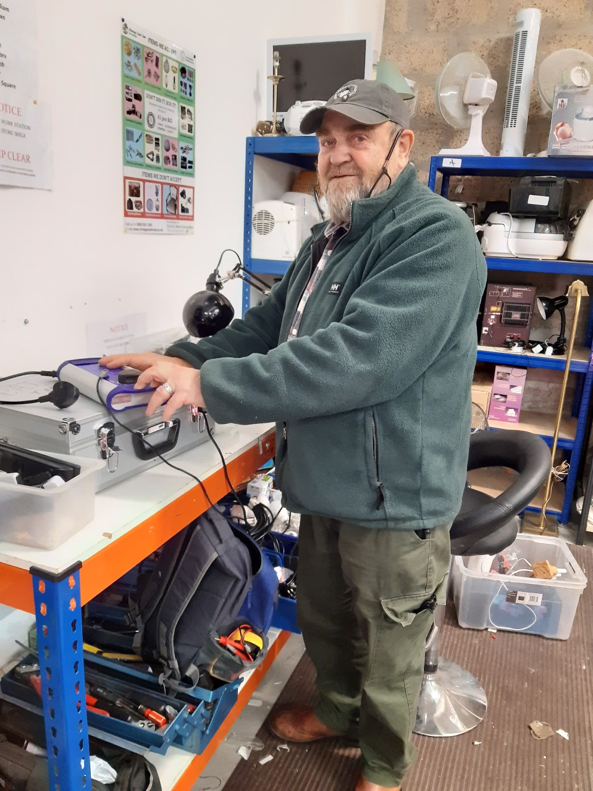
Aim or goal of position:

Main responsibilities:
- Inspecting and testing small household electrical items to ensure they are in working order prior to selling in our shops including visual inspection of plugs, wiring and fuses
- Conduct thorough testing of electrical goods to ensure compliance with safety standards.
- Maintain accurate records of all testing and outcomes including labelling of goods
- Ensure health and safety requirements are followed and maintained

Skills / attributes and/or qualification(s) required:

- Prior maintenance or electrical experience – ideally previous experience of PAT testing
- Be able to carry out tasks independently but also work as part of the Warehouse team
- Attention to detail
- Be reliable and punctual
- Be polite and helpful to others
- Be flexible and willing to respond to change
- Be willing to undertake online PAT Testing training prior to starting

Estimated hours: Just a few hours a week can make a huge difference. Shifts available are Monday- Friday 9am-5pm or Saturday 10 – 5pm.

Training:
- Online PAT testing course prior to starting
- Induction
- Shadow training shifts
- Moving and Handling (inanimate objects) – 2 yearly (1 hour)
- Fire Safety Awareness – annually (1 hour)

Work site:
Highland Hospice Warehouse, Unit 2 & 4, 39 - 41 Harbour Road, Inverness,IV1 1UA

Benefits to the volunteer:

- Give something back to your community
- Work as part of a great team
- Gain confidence
- Enjoy the social benefits that volunteering offers
- Have fun

Start Date: As soon as possible once training is complete

Number of volunteers sought for this role?
Two or three volunteers to support the warehouse across the week

Role supervisor(s): Shirlee Lumsden, Warehouse Manager

For further information contact the Volunteer Office on 01463 227902 or
email volunteer@highlandhospice.org.uk

You can apply online at: Apply Online

