
Rehabilitation and Wellbeing Referral Form - Confidential

Ness House, 1 Bishops Road, Inverness, IV3 5SB
Clinical Support Office (Direct Line: 01463 227901)
email: nhsh.hospicereferrals@nhs.scot
For more information about our services please visit the Highland Hospice website Rehabilitation and Wellbeing | Highland Hospice or feel free to call one of the team on the numbers above.
Essential Client/Patient Information
CHI Number: | DOB: | Age:
Surname:  Forename(s):  Known as:  M / F | NOK Name:  Relationship:
Current Address: | NoK Address:  Telephone:
Telephone:  Mobile:  Email: | GP Name:  Surgery address:  Tel No:
Essential Referral Information
Consent for referral and information sharing obtained from patient?
(Consent is required, if ‘No’ please give a reason e.g. capacity) Yes ☐ No ☐
Principal Diagnosis: | Diagnosis Date:
PPS Score at Present:  (See table overleaf if unsure) | PPS Score 3 months previous:  (Estimated if unsure)  This gives us a better understanding of the patient’s trajectory
Diagnosis details and current treatment:

Patients understanding of diagnosis and prognosis:
Reasons for referral – please outline the circumstances and/or changes in presentation which prompted this referral for a specialist palliative AHP assessment

Support currently in place – (e,g, homecare, specialist nurse, family situation)

Other relevant information including risks - (e.g. key medical history, psychiatry, mobility, infection, allergies, cognition, risk to others)

Referrer Name:  Designation:  Signature: | Telephone Number:  Email Address:  Date:

Palliative Performance Scale

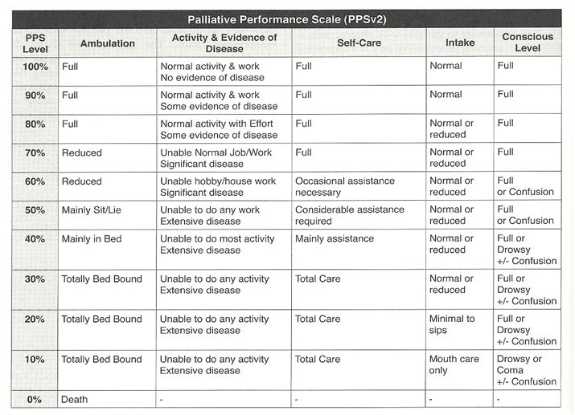
For enquiries regarding Inpatient Unit (IPU) or Medical Outpatient Review please contact Clinical Support Office directly on (01463 227901) Mon-Fri (0830 – 1600hrs) email: nhsh.hospicereferrals@nhs.scot

For Bereavement Support please contact the Bereavement Officer directly on (07709717586) Mon-Thu (0830 – 1630hrs) email bereavement@highlandhospice.org.uk

Management of personal data by Highland Hospice conforms to all current legislative requirements.
You can find our full Privacy Notice on our website highlandhospice.org/privacy.

F07001B

