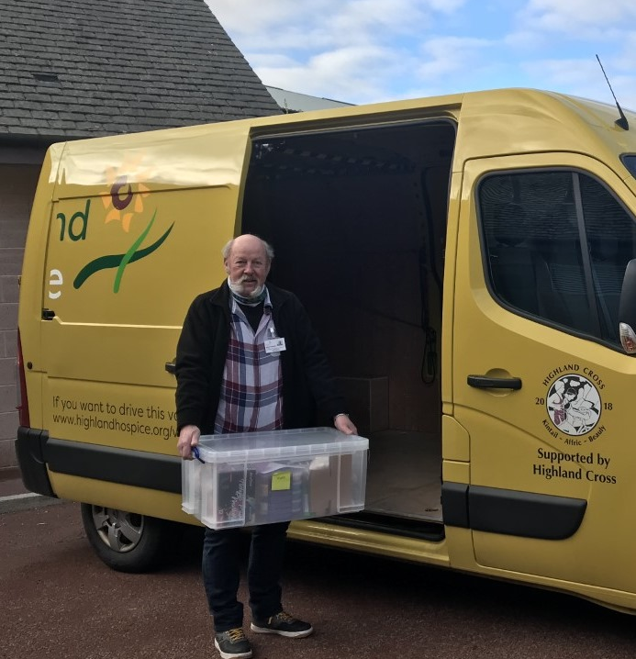


Fundraising and Retail Van Driver
Volunteer Role Description

Aim or goal of position:
To drive the fundraising and retail van which transports donated goods to and from our shops for selling to the public and to drive the van and help out at occasional fundraising events. These activities are a crucial part of income generation for Highland Hospice.

Main responsibilities:
- To drive the van from Inverness to various Highland locations to transport goods for selling to the public. Locations include Alness, Aviemore, Dornoch, Forres, Fort William, Grantown, Nairn, Portree, Tain, Thurso and Wick.
- From time to time there may be additional requests to transport and/or collect items out with normal shifts.
- Drivers may also choose to help at fundraising events, these are arranged on an ad hoc basis.
- To observe all health and safety regulations and policies in regard to safe driving and manual handling.
Skills / attributes and/or qualification(s) required:
- A full driving license (preferably without endorsements) held for at least 2 years
- Must enjoy driving
- Reliability is crucial to the effective and efficient running of this fast-paced role
- Van drivers must be aged 21 and over (for insurance purposes)
- Must be able to work as part of a team
- All Volunteer Van Drivers must complete driver assessment before commencing the role. The assessment is arranged by Highland Hospice at no cost to the volunteer
- A good level of fitness is required for this role as it can be physically demanding when lifting and moving items (Some of our premises are over 2 floors with no lift access)

Hours: Van leaves from the Hospice at a time arranged by mutual agreement. A shift is a full day.

Scheduling: Ideally one day per week or fortnight but at least one day a month.

Length of commitment sought: Open ended
Work site: Van is based at the Highland Hospice Warehouse, 39 – 41 Harbour Road, Inverness, IV1 1UA.

Benefits to the volunteer:
- Opportunity to socialise and meet new people

- Opportunity to work with a great team
- Receive a certificate upon successful completion of a driving assessment
- Satisfaction that you are contributing to Highland Hospice fundraising

Training:
- Induction (at the warehouse)
- Loading training (2 hours)
- Fire Safety – online (30 mins)
- 3 Shadow training shifts with another volunteer driver
- Driving assessment – Every 4 years (1 hour)

Start Date: To be agreed upon successful completion of the driver training

Number of volunteers sought for this role: Unlimited

Role supervisor(s): Shirlee Lumsden, Warehouse Manager, Retail

For further information and application contact the Volunteer Office on 01463 227902 or email volunteer@highlandhospice.org.uk

